**5thWeek Assignment**

**by**

**Jui Ying Lee, Edward Hsu, Heting Xu**

**ITC 6355 Web Application Design & Development**

**Professor Amin Karimpour**

**June 28, 2022**

**Project Description**

The project I would like to implement is an online market management system focusing on trading trending clothes or shoes. This small business named as “Delphpreme” which is owned by my husband and his friends. The reason why I choose this project is I want to design an user-friendly system/platform for all people to use and also build a community for everyone to share their experiences.

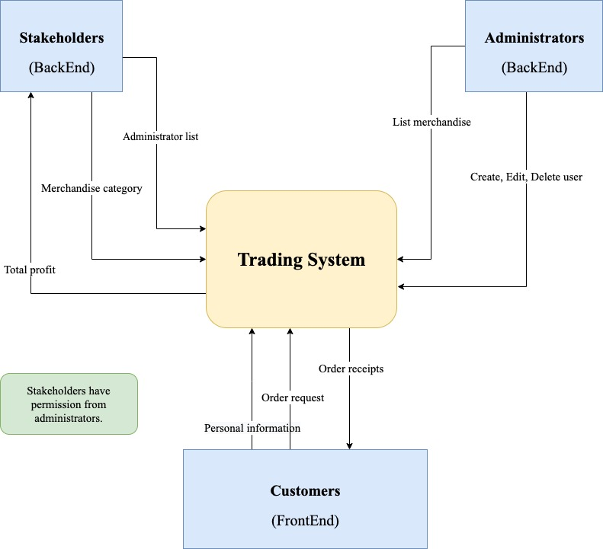The website will operate similar to a stock market-style platform and enable for buyer to bids the items they like and also sellers can list their items for sale. From designing the components, the trading system will have to pass and receive important data from both Backend and Frontend. It will be clear to know who and what’s the responsibilities will be include in the system diagram:

*(Figure 1: System Diagram)*

The scope that will be implemented from Login page to transaction page. In each pages, user will see the tips for each features such as tags, category lists…etc. Detail pages drafted as below:

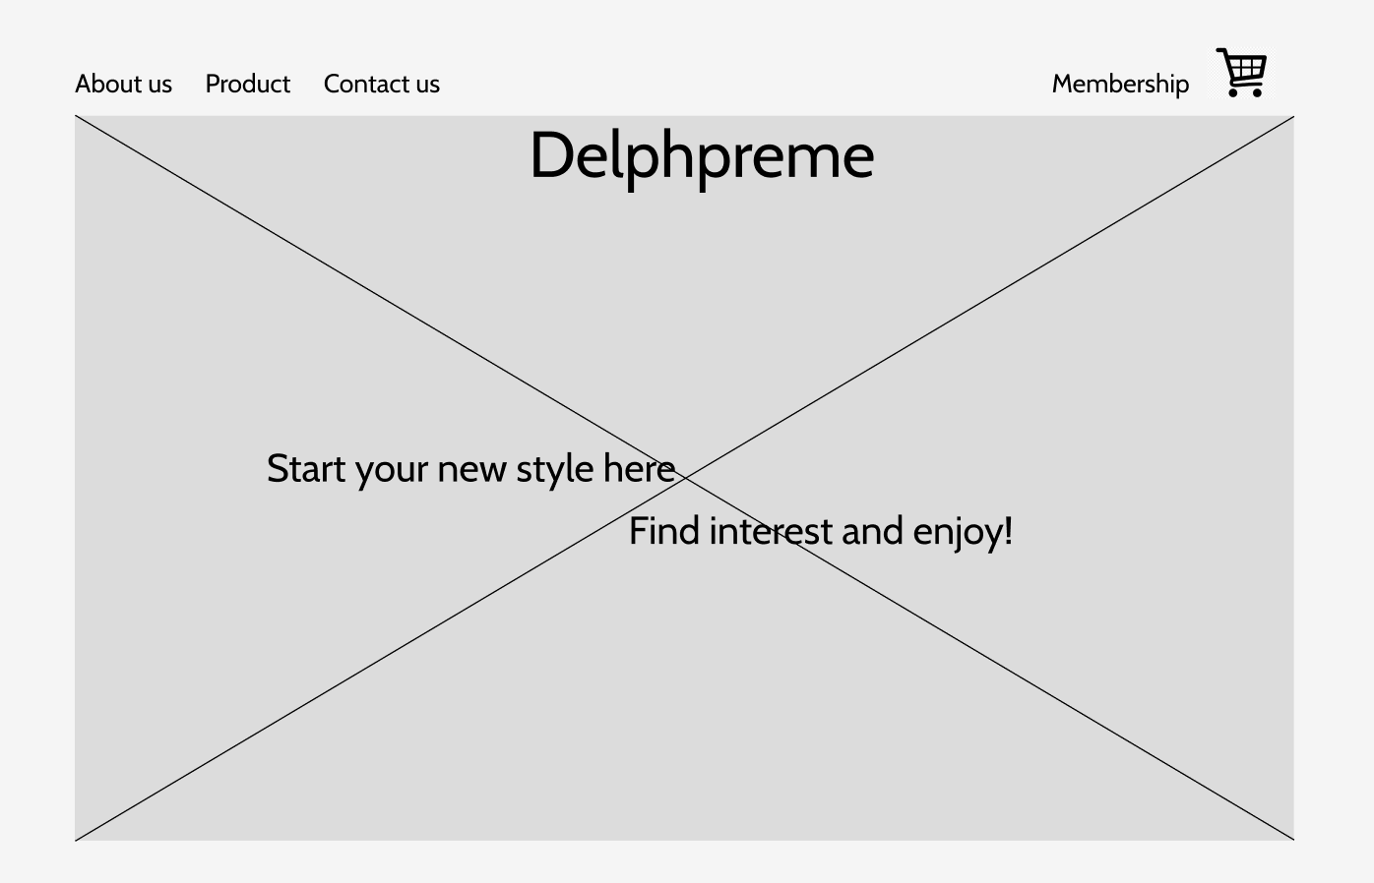

*Figure 2, Homepage*

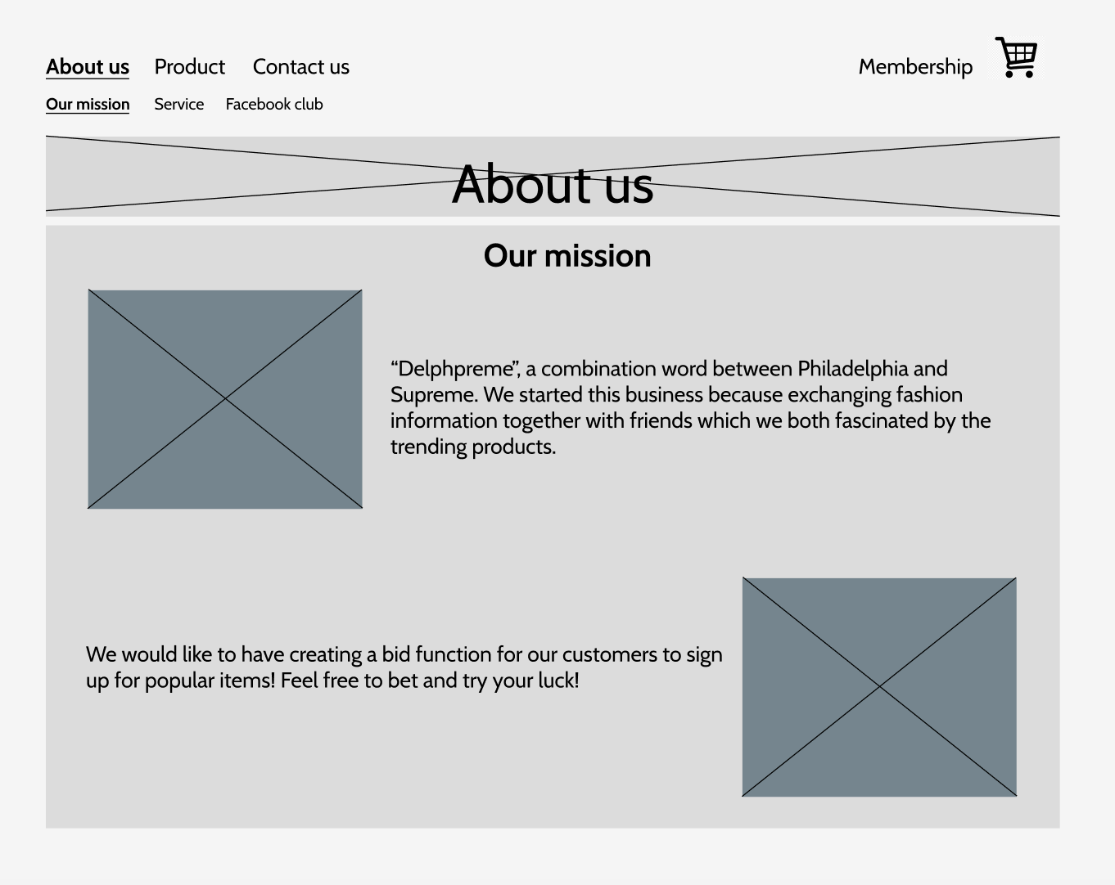

*Figure 3, About us*

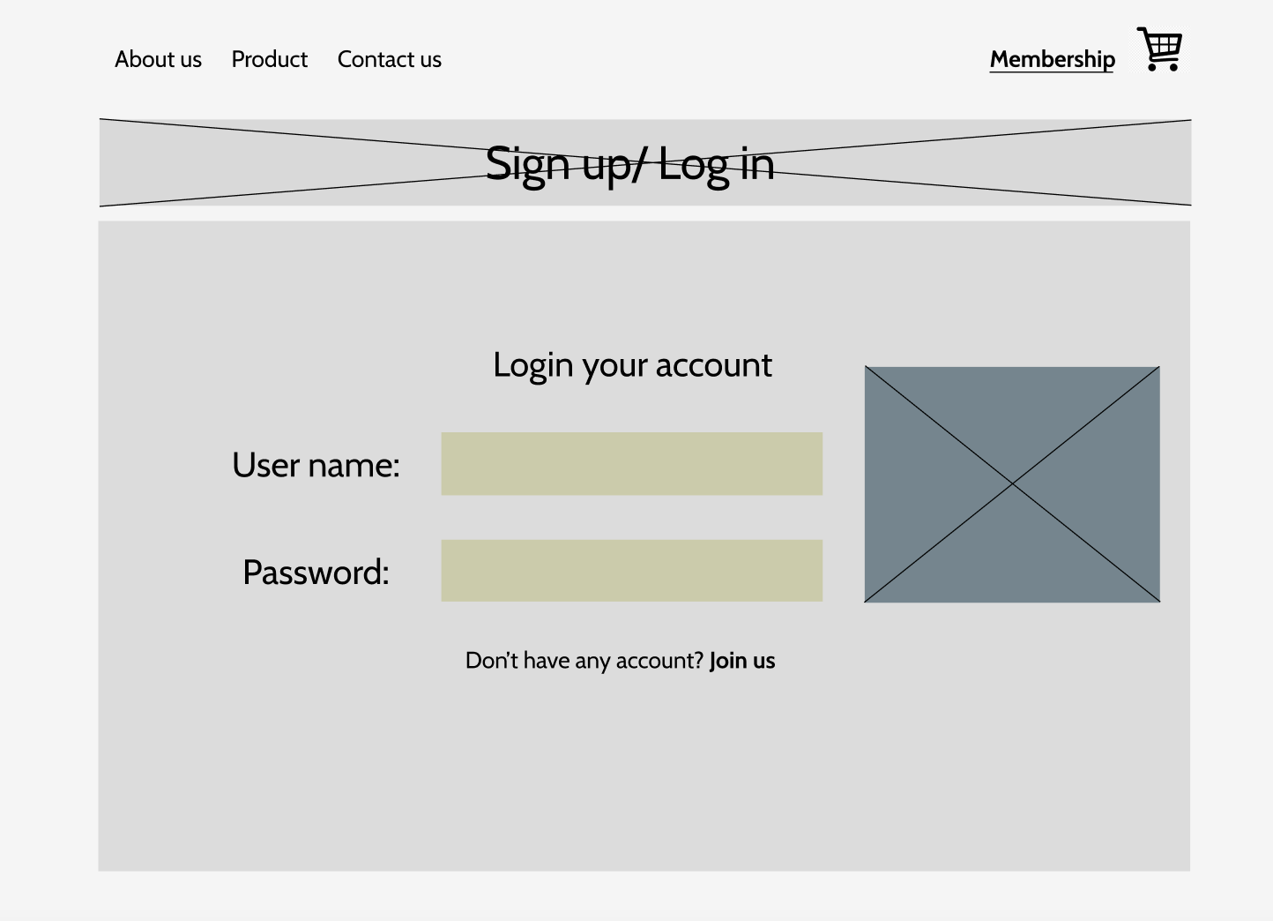

*Figure 4, Sign up/Log in*

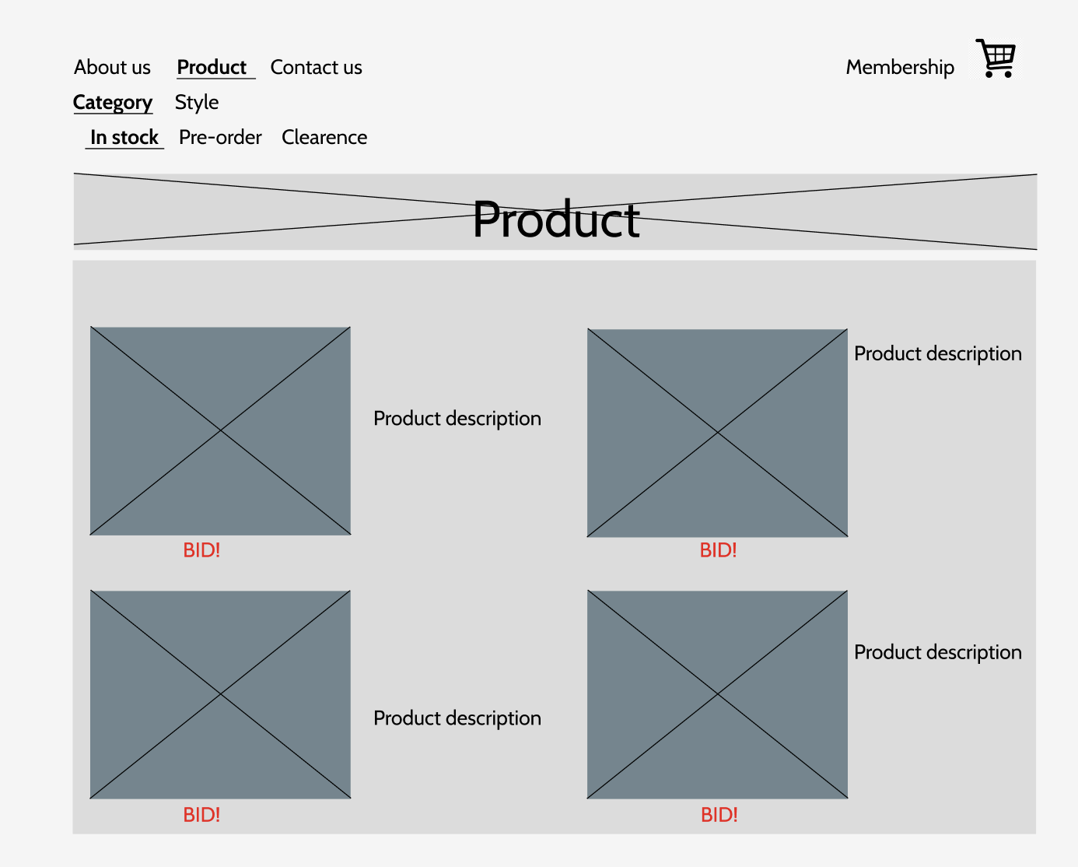

*Figure 5, Product list page*

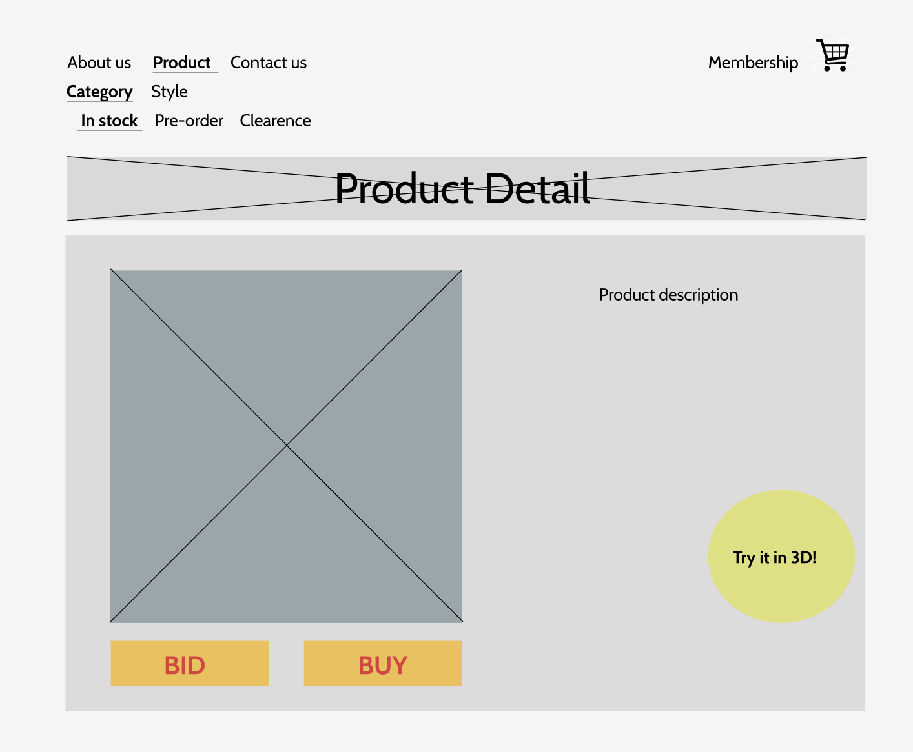

*Figure6, Product detail page*

In each page like About us, user will learn the history of the business, services introductions and Facebook club external links displayed at the top of the category lists which they can be directed to by clicking the button. The drafted menu lists is designed as below sitemap:

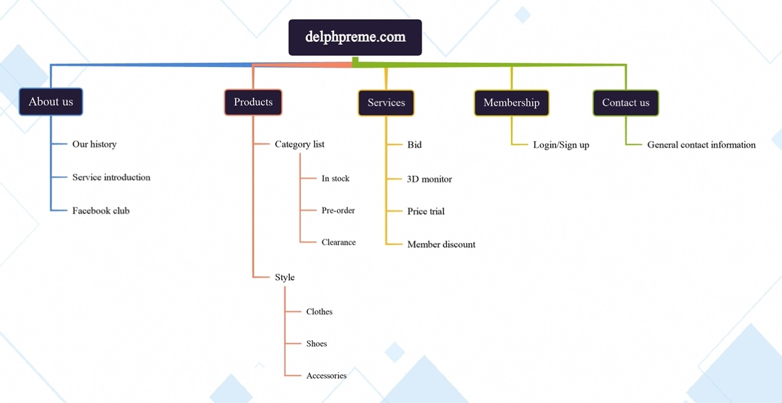

**Project Implementation:**

**HTML5/CSS**

Changes (More detail will be introduced below):

* Add Databases to each page that need input value
* Link DBs by using express and node.js

1. **Home page - HTML:**

<!DOCTYPE *html*>

<html>

<head>

<meta *charset*="UTF-8" />

<meta *name*="viewport" *content*="width=device-width, initial-scale=1.0" />

<title>Delphpreme - Home</title>

<link *rel*="stylesheet" *href*="/styles/homepage.css" *type*="text/css" />

<link

*href*="https://fonts.googleapis.com/css2?family=Playfair:ital,wght@1,500&family=Tilt+Prism&display=swap"

*rel*="stylesheet"

/>

</head>

<body>

<header>

<div *class*="top-bar">

<div *class*="left-side">

<ul *class*="categories">

<li><a *href*="aboutus.html">About us</a></li>

<li><a *href*="productlist.html">Product page</a></li>

<li><a *href*="contactus.html">Contact us</a></li>

<li><a *href*="membership.html" *class*="membership icon">Membership</a></li>

<li><a *href*="#" *class*="cart icon">Cart</li></a>

</ul>

</div>

</header>

<p *class*="join-now">

Don't have an account? <a *href*="joinus.html">Join us now</a>

</p>

</section>

*<!-- Link back to the homepage -->*

<a *href*="homepage.html" *class*="back-to-home">Back to Home</a>

*<!-- Other content of the homepage -->*

</body>

</html>

**Home Page – CSS:**

a {

color: grey;

font-family: "Tilt Prism", cursive;

font-size: 30px;

text-align: center;

}

a*.membership.icon* {

color: orange;

font-family: "Tilt Prism", cursive;

font-size: 30px;

text-align: right;

}

a*.cart.icon* {

color: orange;

font-family: "Tilt Prism", cursive;

font-size: 30px;

text-align: right;

}

h1 {

color: black;

font-family: "Playfair", serif;

font-size: large;

text-align: center;

}

*.categories* {

display: flex;

justify-content: space-between;

}

body {

background-image: url("/images/jordan2.jpeg");

background-size: cover;

background-repeat: no-repeat;

width: 900px;

height: 900px;

margin: 0 auto;

background-color: aliceblue;

padding: 0 40px 40px 40px;

border: 5px solid black;

}

*.join-now*,

*.back-to-home* {

position: fixed;

left: 0;

right: 0;

text-align: center;

bottom: 20px;

}

*.back-to-home* {

bottom: 0;

}

**Home Page – Live Browser:**

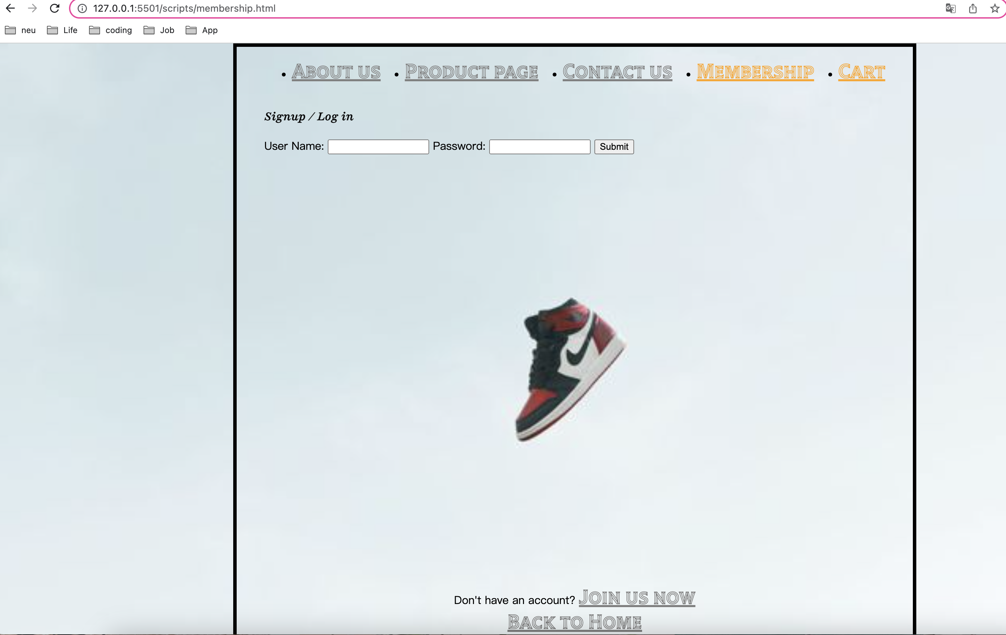

* **About Us Page - HTML:**

<!DOCTYPE *html*>

<html>

<head>

<meta *charset*="UTF-8" />

<meta *name*="viewport" *content*="width=device-width, initial-scale=1.0" />

<title>Delphpreme - About Us</title>

<link *rel*="stylesheet" *href*="/styles/aboutus.css" *type*="text/css" />

<link

*href*="https://fonts.googleapis.com/css2?family=Playfair:ital,wght@1,500&family=Tilt+Prism&display=swap"

*rel*="stylesheet"

/>

</head>

<body>

<header>

<div *class*="top-bar">

<div *class*="left-side">

<ul *class*="categories">

<li><a *href*="aboutus.html">About us</a></li>

<li><a *href*="productlist.html">Product page</a></li>

<li><a *href*="contactus.html">Contact us</a></li>

<li><a *href*="membership.html" *class*="membership icon">Membership</a></li>

</ul>

</div>

</header>

<main>

<section *class*="page-title">

<h1>About Us</h1>

</section>

<section *class*="content-section">

<div *class*="left-side">

<figure>

<img

*src*="/images/delphpreme.jpg"

*alt*="delphpreme logo"

*width*="500"

*height*="200"

/>

<figcaption>

"Delphpreme" A combination word between Philadelphia and Supreme.

We started this business because exchanging fashion information

together with friends which we both fascinated by the trending

products.

</figcaption>

</figure>

</div>

<section *class*="page-subtitle">

<h2>Our Mission</h2>

</section>

<div *class*="right-side">

<figure>

<img

*src*="/images/onfire.jpeg"

*alt*="On Fire"

*width*="350"

*height*="200"

/>

<figcaption>

We would like to have creating a bid function for our customers to

sign up for popular items! Feel free to bet and try your luck!

</figcaption>

</figure>

</div>

</section>

<p *class*="join-now">

Don't have an account? <a *href*="joinus.html">Join us now</a>

</p>

</section>

*<!-- Link back to the homepage -->*

<a *href*="homepage.html" *class*="back-to-home">Back to Home</a>

<footer>

*<!-- Footer content -->*

</footer>

</body>

</html>

**About Us Page – CSS**

a {

color: grey;

font-family: "Tilt Prism", cursive;

font-size: 30px;

text-align: left;

}

a*.membership.icon* {

color: orange;

font-family: "Tilt Prism", cursive;

font-size: 30px;

text-align: right;

}

a*.cart.icon* {

color: orange;

font-family: "Tilt Prism", cursive;

font-size: 30px;

text-align: right;

}

h1 {

color: black;

font-family: "Playfair", serif;

font-size: larger;

text-align: left;

margin: 0;

padding: 20px 0;

color: black;

}

h2 {

color: black;

font-family: "Playfair", serif;

font-size: larger;

text-align: left;

margin: 0;

padding: 20px 0;

color: black;

}

figcaption {

color: rgb(64, 111, 191);

font-family: "Playfair", serif;

font-size: medium;

text-align: center;

}

*.categories* {

display: flex;

justify-content: space-between;

}

body {

background-image: url("/images/jordan2.jpeg");

background-size: cover;

background-repeat: no-repeat;

width: 900px;

height: 900px;

margin: 0 auto;

background-color: aliceblue;

padding: 0 40px 40px 40px;

border: 5px solid black;

}

img {

display: block;

margin: 0 auto;

}

*.join-now*,

*.back-to-home* {

position: fixed;

left: 0;

right: 0;

text-align: center;

bottom: 20px;

}

*.back-to-home* {

bottom: 0;

}

**About Us Page – Live Browser:**

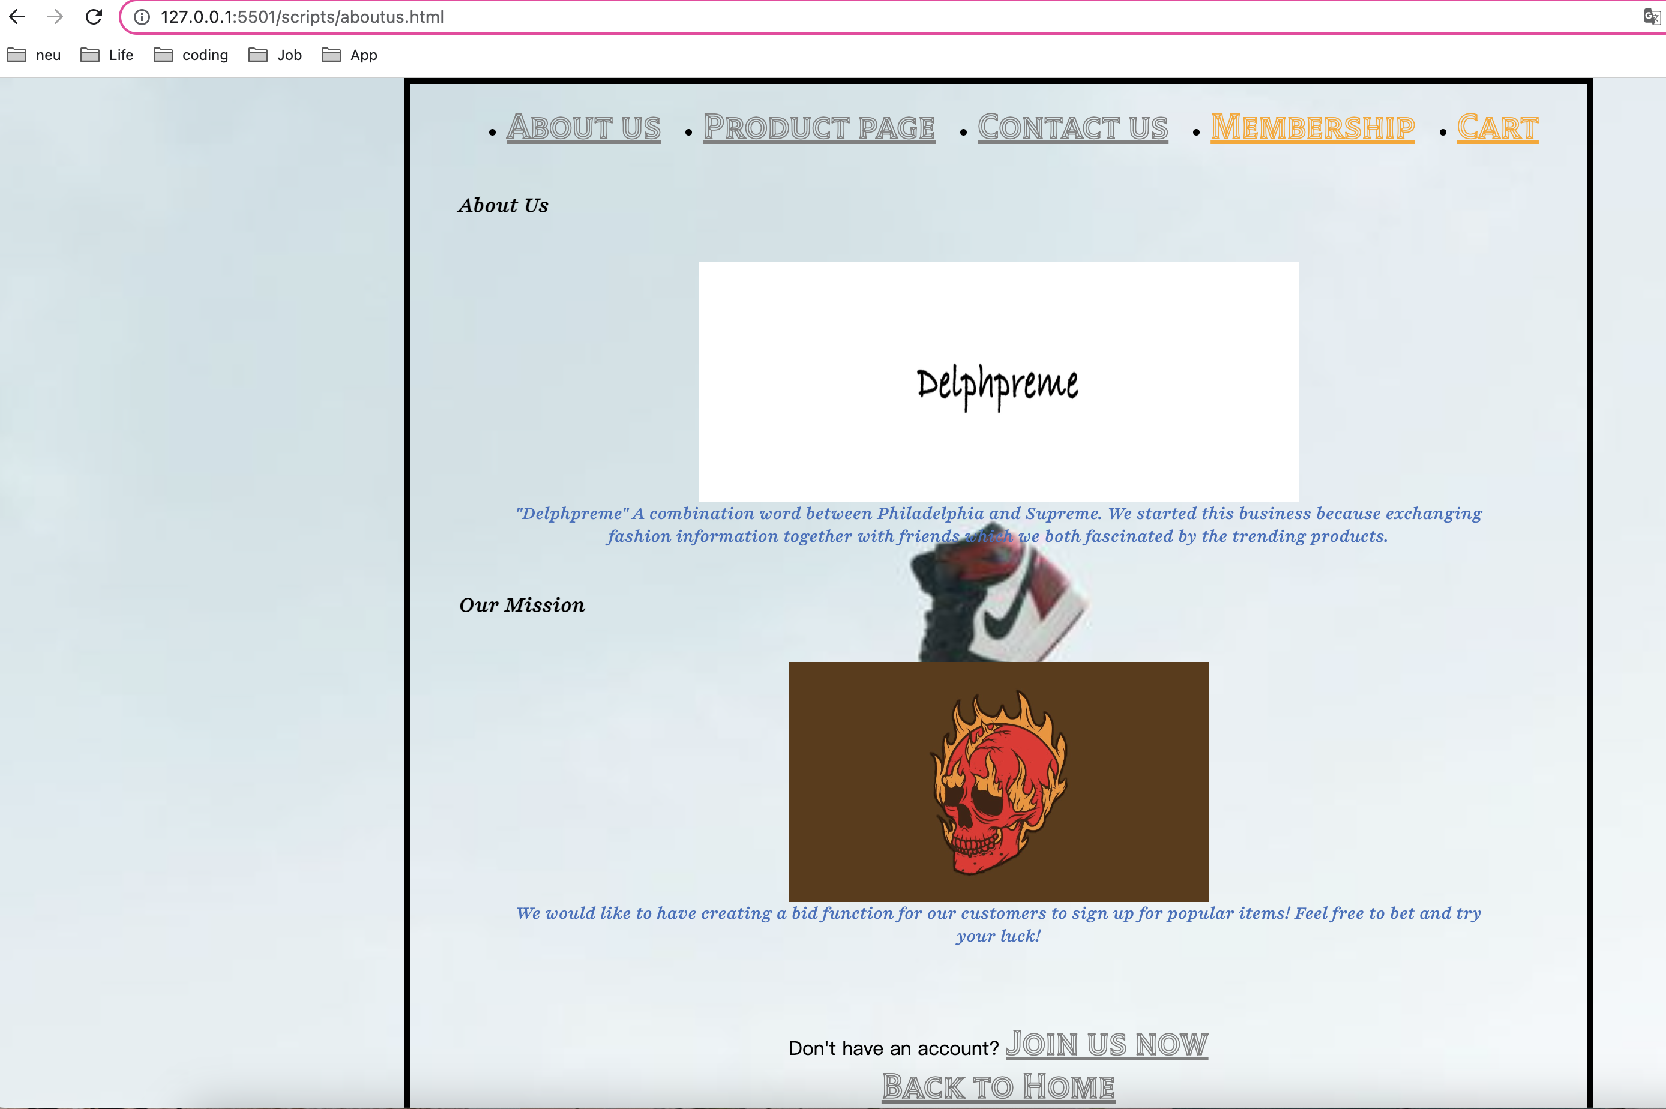

* **Membership page -HTML:**

<!DOCTYPE *html*>

<html>

<head>

<meta *charset*="UTF-8" />

<meta *name*="viewport" *content*="width=device-width, initial-scale=1.0" />

<title>Delphpreme - Membership</title>

<link *rel*="stylesheet" *href*="/styles/membership.css" *type*="text/css" />

<script *src*="main.js"></script>

<link

*href*="https://fonts.googleapis.com/css2?family=Playfair:ital,wght@1,500&family=Tilt+Prism&display=swap"

*rel*="stylesheet"

/>

</head>

<body>

<header>

<div *class*="top-bar">

<div *class*="left-side">

<ul *class*="categories">

<li><a *href*="aboutus.html">About us</a></li>

<li><a *href*="productlist.html">Product page</a></li>

<li><a *href*="contactus.html">Contact us</a></li>

<li>

<a *href*="membership.html" *class*="membership icon">Membership</a>

</li>

</ul>

</div>

</div>

</header>

<main>

<section *class*="page-title">

<h1>Signup / Log in</h1>

</section>

<section *class*="login-form">

<form *id*="login-form">

<div *id*="error-container"></div>

<label *for*="username">User Name:</label>

<input *type*="text" *id*="username" *name*="username" *required* />

<label *for*="password">Password:</label>

<input *type*="password" *id*="password" *name*="password" *required* />

<input *type*="submit" *value*="Submit" />

</form>

<p *class*="join-now">

Don't have an account? <a *href*="joinus.html">Join us now</a>

</p>

</section>

*<!-- Link back to the homepage -->*

<a *href*="homepage.html" *class*="back-to-home">Back to Home</a>

</main>

<footer>

*<!-- Footer content -->*

</footer>

</body>

</html>

**Membership Page – CSS**

a {

color: grey;

font-family: "Tilt Prism", cursive;

font-size: 30px;

text-align: left;

}

a*.membership.icon* {

color: orange;

font-family: "Tilt Prism", cursive;

font-size: 30px;

text-align: right;

}

h1 {

color: black;

font-family: "Playfair", serif;

font-size: larger;

text-align: left;

margin: 0;

padding: 20px 0;

color: black;

}

h2 {

color: black;

font-family: "Playfair", serif;

font-size: larger;

text-align: left;

margin: 0;

padding: 20px 0;

color: black;

}

*.join-now* {

position: fixed;

left: 0;

right: 0;

text-align: center;

bottom: 20px;

}

*.back-to-home* {

bottom: 0;

}

*.categories* {

display: flex;

justify-content: space-between;

}

body {

background-image: url("/images/jordan2.jpeg");

background-size: cover;

background-repeat: no-repeat;

width: 900px;

height: 900px;

margin: 0 auto;

background-color: aliceblue;

padding: 0 40px 40px 40px;

border: 5px solid black;

}

img {

display: block;

margin: 0 auto;

}

*.error-container* {

display: flex;

align-items: center;

margin-top: 5px;

color: red;

}

*.error-message* {

margin-left: 5px;

font-size: 14px;

font-weight: bolder;

color: red;

}

**Membership page – Live Browser**

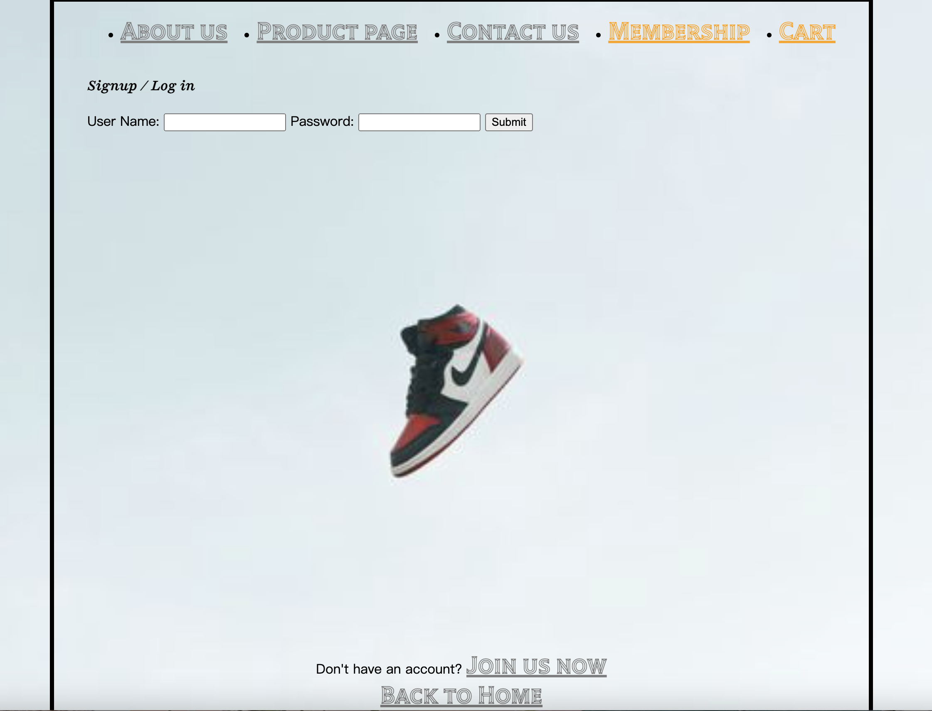

* **Product List Page - HTML:**

<!DOCTYPE *html*>

<html>

<head>

<meta *charset*="UTF-8" />

<meta *name*="viewport" *content*="width=device-width, initial-scale=1.0" />

<title>Delphpreme - Product List</title>

<link *rel*="stylesheet" *href*="/styles/productlist.css" *type*="text/css" />

<link

*href*="https://fonts.googleapis.com/css2?family=Playfair:ital,wght@1,500&family=Tilt+Prism&display=swap"

*rel*="stylesheet"

/>

</head>

<body>

<header>

<div *class*="top-bar">

<div *class*="left-side">

<ul *class*="categories">

<li><a *href*="aboutus.html">About us</a></li>

<li><a *href*="productlist.html">Product page</a></li>

<li><a *href*="contactus.html">Contact us</a></li>

<li><a *href*="membership.html" *class*="membership icon">Membership</a></li>

</ul>

</div>

</header>

<main>

<section *class*="page-title">

<h1>Product</h1>

</section>

<section *class*="product-lists">

<div *class*="left-side1">

<a *href*="productdetail.html">

<figure>

<img *src*="/images/aj1.jpeg" *alt*="product 1" *width*="250" *height*="200" />

<figcaption>The Latest Airjordan 1</figcaption>

</figure>

</a>

</div>

<div *class*="left-side2">

<figure>

<img

*src*="/images/aj2.jpeg"

*alt*="product 2"

*width*="350"

*height*="200"

/>

<figcaption>The Latest Airjordan 1-2</figcaption>

</figure>

</div>

<div *class*="right-side1">

<figure>

<img

*src*="/images/aj3.jpeg"

*alt*="Product 3"

*width*="350"

*height*="200"

/>

<figcaption>The Latest Airjordan 1-3</figcaption>

</figure>

</div>

<div *class*="right-side2">

<figure>

<img

*src*="/images/aj4.jpeg"

*alt*="product 4"

*width*="350"

*height*="200"

/>

<figcaption>The Latest Airjordan 1-4</figcaption>

</figure>

</div>

</section>

*<!-- Link back to the homepage -->*

<a *href*="homepage.html">Back to Home</a>

</main>

<footer>

*<!-- Footer content -->*

</footer>

</body>

</html>

**Product List Page – CSS**

a {

color: grey;

font-family: "Tilt Prism", cursive;

font-size: 30px;

text-align: left;

}

a*.membership.icon* {

color: orange;

font-family: "Tilt Prism", cursive;

font-size: 30px;

text-align: right;

}

a*.cart.icon* {

color: orange;

font-family: "Tilt Prism", cursive;

font-size: 30px;

text-align: right;

}

h1 {

color: black;

font-family: "Playfair", serif;

font-size: xx-large;

text-align: left;

margin: 0;

padding: 20px 0;

color: black;

}

h2 {

color: black;

font-family: "Playfair", serif;

font-size: larger;

text-align: left;

margin: 0;

padding: 20px 0;

color: black;

}

*.join-now*,

*.back-to-home* {

position: fixed;

left: 0;

right: 0;

text-align: center;

bottom: 20px;

}

*.back-to-home* {

bottom: 0;

}

*.categories* {

display: flex;

justify-content: space-between;

}

body {

background-image: url("/images/jordan2.jpeg");

background-size: cover;

background-repeat: no-repeat;

width: 1000px;

height: 1400px;

margin: 0 auto;

background-color: aliceblue;

padding: 0 40px 40px 40px;

border: 5px solid black;

}

img {

display: block;

margin: 0 auto;

}

figcaption {

color: red;

display: flex;

justify-content: center;

align-items: center;

}

**Product List Page – Live Browser:**

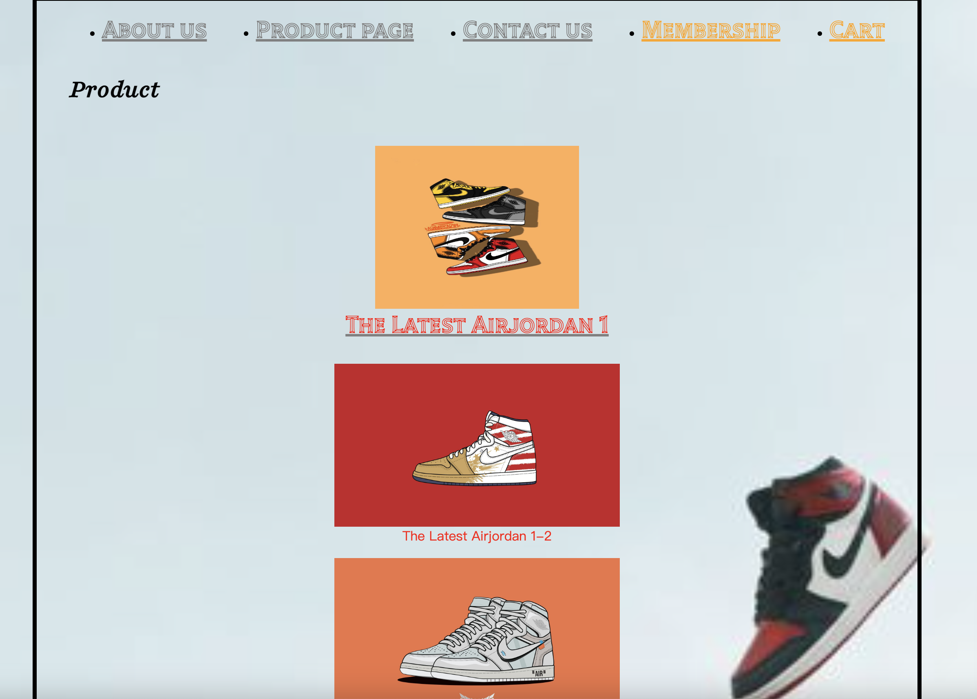

* **Product Detail Page - HTML:**

<!DOCTYPE *html*>

<html>

<head>

<meta *charset*="UTF-8" />

<meta *name*="viewport" *content*="width=device-width, initial-scale=1.0" />

<title>Delphpreme - Product Detail</title>

<link *rel*="stylesheet" *href*="/styles/productdetail.css" *type*="text/css" />

<link

*href*="https://fonts.googleapis.com/css2?family=Playfair:ital,wght@1,500&family=Tilt+Prism&display=swap"

*rel*="stylesheet"

/>

</head>

<body>

<header>

<div *class*="top-bar">

<div *class*="left-side">

<ul *class*="categories">

<li><a *href*="aboutus.html">About us</a></li>

<li><a *href*="productlist.html">Product page</a></li>

<li><a *href*="contactus.html">Contact us</a></li>

<li><a *href*="membership.html" *class*="membership">Membership</a></li>

</ul>

</div>

</div>

</header>

<main>

<section *class*="product-detail">

<div *class*="left-side">

<figure>

<img

*src*="/images/aj1.jpeg"

*alt*="Product 1"

*width*="400"

*height*="350"

/>

</figure>

</div>

<div *class*="right-side">

<h2>Air Jordan 1</h2>

<h2>Current Price: $300</h2>

<p *class*="product-description">Retro Style of Nike, Air Jordan.</p>

<div *class*="buttons">

<button *class*="bid-button">BID</button>

<button *class*="buy-button">BUY</button>

</div>

</div>

</section>

<button *class*="try-3d-button">Try it in 3D!</button>

*<!-- Link back to the homepage -->*

<a *href*="homepage.html">Back to Home</a>

</main>

<footer>

*<!-- Footer content -->*

</footer>

</body>

</html>

**Product Detail Page – CSS:**

a {

color: grey;

font-family: "Tilt Prism", cursive;

font-size: 30px;

text-align: left;

}

a*.membership.icon* {

color: orange;

font-family: "Tilt Prism", cursive;

font-size: 30px;

text-align: right;

}

a*.cart.icon* {

color: orange;

font-family: "Tilt Prism", cursive;

font-size: 30px;

text-align: right;

}

h1 {

color: black;

font-family: "Playfair", serif;

font-size: larger;

text-align: left;

margin: 0;

padding: 20px 0;

color: black;

}

h2 {

color: black;

font-family: "Playfair", serif;

font-size: larger;

text-align: left;

margin: 0;

padding: 20px 0;

color: black;

}

*.join-now*,

*.back-to-home* {

position: fixed;

left: 0;

right: 0;

text-align: center;

bottom: 20px;

}

*.back-to-home* {

bottom: 0;

}

*.categories* {

display: flex;

justify-content: space-between;

}

body {

background-image: url("/images/jordan2.jpeg");

background-size: cover;

background-repeat: no-repeat;

width: 1000px;

height: 1400px;

margin: 0 auto;

background-color: aliceblue;

padding: 0 40px 40px 40px;

border: 5px solid black;

}

img {

display: block;

margin: 0 auto;

}

**Product Detail Page – Live Browser:**

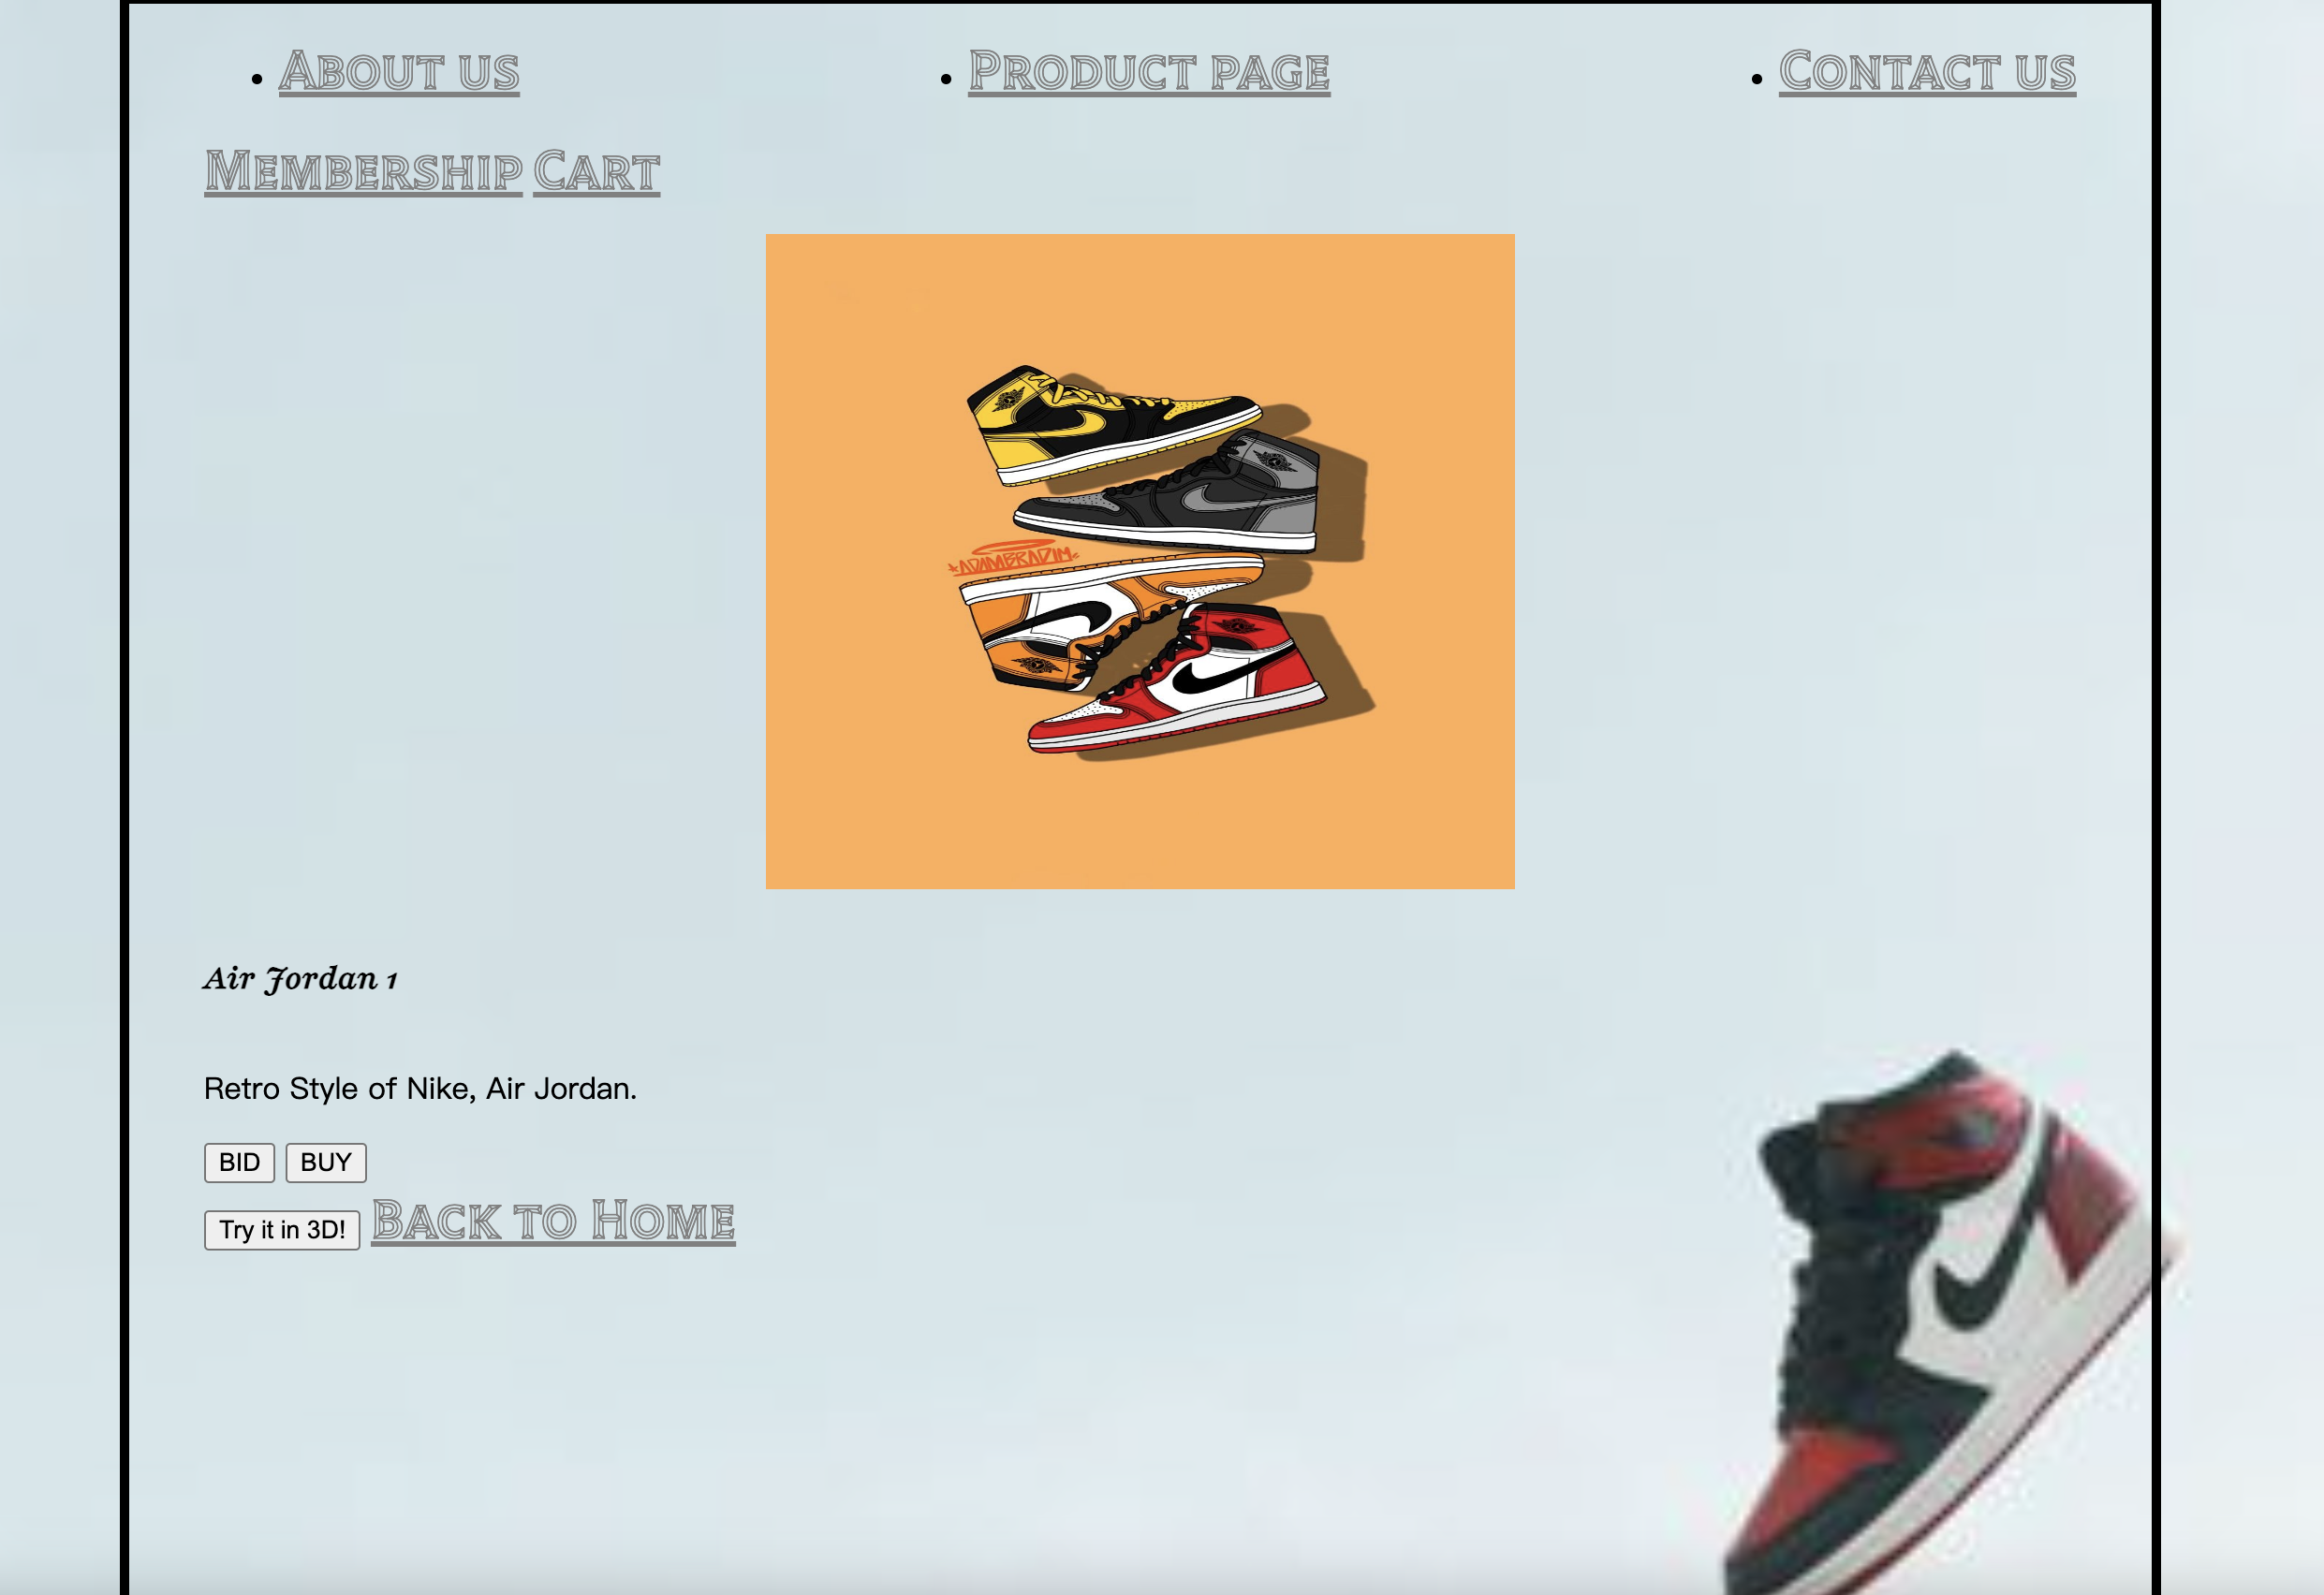

**Join Us Page – HTML**

<!DOCTYPE *html*>

<html>

<head>

<meta *charset*="UTF-8" />

<meta *name*="viewport" *content*="width=device-width, initial-scale=1.0" />

<title>Delphpreme - Join Us</title>

<link *rel*="stylesheet" *href*="/styles/joinus.css" *type*="text/css" />

<script *src*="main.js"></script>

<link

*href*="https://fonts.googleapis.com/css2?family=Playfair:ital,wght@1,500&family=Tilt+Prism&display=swap"

*rel*="stylesheet"

/>

</head>

<body>

<header>

<div *class*="top-bar">

<div *class*="left-side">

<ul *class*="categories">

<li><a *href*="aboutus.html">About us</a></li>

<li><a *href*="productlist.html">Product page</a></li>

<li><a *href*="contactus.html">Contact us</a></li>

<li>

<a *href*="membership.html" *class*="membership icon">Membership</a>

</li>

</ul>

</div>

</div>

</header>

<main>

<section *class*="page-title">

<h1>Create an Account</h1>

</section>

<section *class*="membership-form">

<form *id*="membership-form">

<label *for*="First name">First name:</label>

<input *type*="text" *id*="firstname" *name*="firstname" *required* />

<label *for*="Last name">Last Name:</label>

<input *type*="text" *id*="lastname" *name*="lastname" *required* />

<label *for*="username">User Name:</label>

<input *type*="text" *id*="username" *name*="username" *required* />

<label *for*="password">Password:</label>

<input *type*="password" *id*="password" *name*="password" *required* />

<label *for*="Email Address">Email Address:</label>

<input *type*="text" *id*="email" *name*="email" *required* />

<label *for*="Phone number">Phone number:</label>

<input *type*="number" *id*="phone" *name*="phone" *required* />

<input *type*="submit" *value*="Submit" />

</form>

</section>

*<!-- Link back to the homepage -->*

<a *href*="homepage.html" *class*="back-to-home">Back to Home</a>

</main>

<footer>

*<!-- Footer content -->*

</footer>

</body>

</html>

**Join Us Page – CSS**

a {

color: grey;

font-family: "Tilt Prism", cursive;

font-size: 30px;

text-align: left;

}

a*.membership.icon* {

color: orange;

font-family: "Tilt Prism", cursive;

font-size: 30px;

text-align: right;

}

a*.cart.icon* {

color: orange;

font-family: "Tilt Prism", cursive;

font-size: 30px;

text-align: right;

}

h1 {

color: black;

font-family: "Playfair", serif;

font-size: larger;

text-align: left;

margin: 0;

padding: 20px 0;

color: black;

}

h2 {

color: black;

font-family: "Playfair", serif;

font-size: larger;

text-align: left;

margin: 0;

padding: 20px 0;

color: black;

}

form label {

display: block;

margin-bottom: 5px;

}

*.join-now*,

*.back-to-home* {

position: fixed;

left: 0;

right: 0;

text-align: center;

bottom: 20px;

}

*.back-to-home* {

bottom: 0;

}

*.categories* {

display: flex;

justify-content: space-between;

}

body {

background-image: url("/images/jordan2.jpeg");

background-size: cover;

background-repeat: no-repeat;

width: 900px;

height: 900px;

margin: 0 auto;

background-color: aliceblue;

padding: 0 40px 40px 40px;

border: 5px solid black;

}

img {

display: block;

margin: 0 auto;

}

*/* Error message styles */*

*.error-container* {

display: flex;

align-items: center;

margin-top: 5px;

color: red;

}

*.error-message* {

margin-left: 5px;

font-size: 14px;

font-weight: bolder;

}

**Join Us Page – Live Browser**

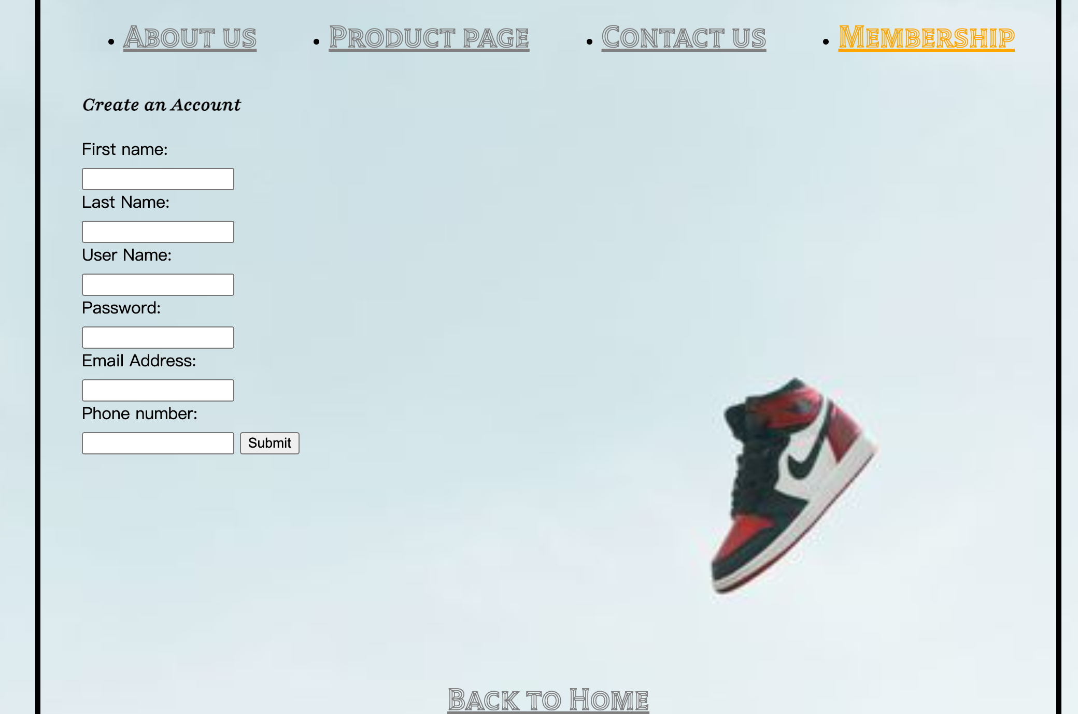

**Contact Us Page – HTML**

<!DOCTYPE *html*>

<html>

<head>

<meta *charset*="UTF-8" />

<meta *name*="viewport" *content*="width=device-width, initial-scale=1.0" />

<title>Delphpreme - Join Us</title>

<link *rel*="stylesheet" *href*="/styles/contactus.css" *type*="text/css" />

<script *src*="main.js"></script>

<link

*href*="https://fonts.googleapis.com/css2?family=Playfair:ital,wght@1,500&family=Tilt+Prism&display=swap"

*rel*="stylesheet"

/>

</head>

<body>

<header>

<div *class*="top-bar">

<div *class*="left-side">

<ul *class*="categories">

<li><a *href*="aboutus.html">About us</a></li>

<li><a *href*="productlist.html">Product page</a></li>

<li><a *href*="contactus.html">Contact us</a></li>

<li>

<a *href*="membership.html" *class*="membership icon">Membership</a>

</li>

</ul>

</div>

</div>

</header>

<main>

<section *class*="page-title">

<h1>Contact Us</h1>

<h2>

Feel free to contact us by phone or email inquiry, we will get back to

you during office hour.

</h2>

</section>

<section>

<h2>Time: From 9 am to 5 pm Monday through Friday</h2>

<h2>Phone number: 201-111-2222</h2>

<h2>

If you have any questions, please feel free to left a message below:

</h2>

</section>

<section *class*="Staff-contact-form">

<form *id*="Staff-contact-form">

<label *for*="First name">First name:</label>

<input *type*="text" *id*="firstname" *name*="firstname" *required* />

<label *for*="Last name">Last Name:</label>

<input *type*="text" *id*="lastname" *name*="lastname" *required* />

<label *for*="Email Address">Email Address:</label>

<input *type*="text" *id*="email" *name*="email" *required* />

<label *for*="Phone number">Phone number:</label>

<input *type*="number" *id*="phone" *name*="phone" *required* />

<label *for*="Inquiry">Inquiry:</label>

<input *type*="text" *id*="inquiry" *name*="inquiry" *required* />

<input *type*="submit" *value*="Submit" />

</form>

</section>

*<!-- Link back to the homepage -->*

<a *href*="homepage.html" *class*="back-to-home">Back to Home</a>

</main>

<footer>

*<!-- Footer content -->*

</footer>

</body>

</html>

**Contact Us Page – CSS**

a {

color: grey;

font-family: "Tilt Prism", cursive;

font-size: 30px;

text-align: left;

}

a*.membership.icon* {

color: orange;

font-family: "Tilt Prism", cursive;

font-size: 30px;

text-align: right;

}

h1 {

color: black;

font-family: "Playfair", serif;

font-size: xx-large;

font-weight: bold;

text-align: center;

margin: 0;

padding: 20px 0;

color: black;

}

h2 {

color: black;

font-family: "Playfair", serif;

font-size: larger;

text-align: ce;

margin: 0;

padding: 20px 0;

color: black;

}

*.join-now*,

*.back-to-home* {

position: fixed;

left: 0;

right: 0;

text-align: center;

bottom: 20px;

}

form label {

display: block;

margin-bottom: 5px;

}

*#inquiry* {

height: 100px;

}

*.back-to-home* {

bottom: 0;

}

*.categories* {

display: flex;

justify-content: space-between;

}

body {

background-image: url("/images/jordan2.jpeg");

background-size: cover;

background-repeat: no-repeat;

width: 900px;

height: 900px;

margin: 0 auto;

background-color: aliceblue;

padding: 0 40px 40px 40px;

border: 5px solid black;

}

img {

display: block;

margin: 0 auto;

}

*.error-container* {

display: flex;

align-items: center;

margin-top: 5px;

color: red;

}

*.error-message* {

margin-left: 5px;

font-size: 14px;

font-weight: bolder;

}

**Contact Us – Live Browser**

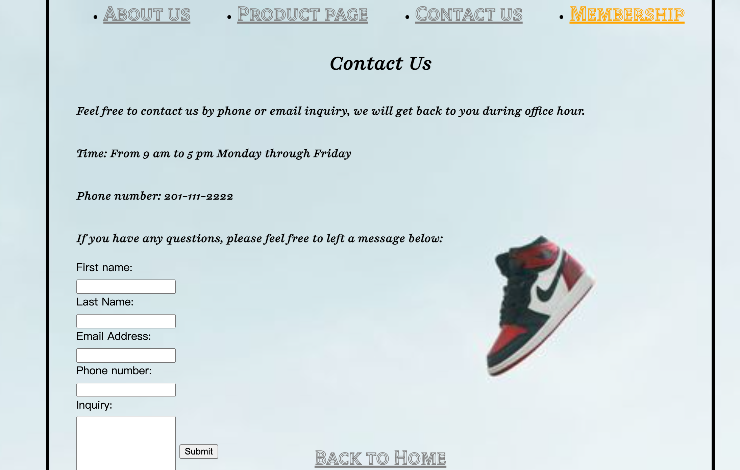

**JavaScript**

(Saving file as main.js)

document.addEventListener("DOMContentLoaded", function () {

const form = document.getElementById("membership-form");

form.addEventListener("submit", function (event) {

event.preventDefault();

validateForm();

});

function validateForm() {

const firstnameInput = document.getElementById("firstname");

const lastnameInput = document.getElementById("lastname");

const usernameInput = document.getElementById("username");

const passwordInput = document.getElementById("password");

const emailInput = document.getElementById("email");

const phoneInput = document.getElementById("phone");

const firstname = firstnameInput.value.trim();

const lastname = lastnameInput.value.trim();

const username = usernameInput.value.trim();

const password = passwordInput.value.trim();

const email = emailInput.value.trim();

const phone = phoneInput.value.trim();

*// Reset previous error messages*

resetErrorMessages();

*// Perform validation checks*

let isValid = true;

*if* (!isValidName(firstname)) {

displayErrorMessage(firstnameInput, "Invalid first name");

isValid = false;

}

*if* (!isValidName(lastname)) {

displayErrorMessage(lastnameInput, "Invalid last name");

isValid = false;

}

*if* (!isValidUsername(username)) {

displayErrorMessage(usernameInput, "Invalid username");

isValid = false;

}

*if* (!isValidPassword(password)) {

displayErrorMessage(passwordInput, "Invalid password");

isValid = false;

}

*if* (!isValidEmail(email)) {

displayErrorMessage(emailInput, "Invalid email address");

isValid = false;

}

*if* (!isValidPhoneNumber(phone)) {

displayErrorMessage(phoneInput, "Invalid phone number");

isValid = false;

}

*// If the form is valid, submit it*

*if* (isValid) {

form.submit();

}

}

function resetErrorMessages() {

const errorMessages = document.querySelectorAll(".error-message");

errorMessages.forEach(function (errorMessage) {

errorMessage.remove();

});

}

function displayErrorMessage(inputElement, message) {

const errorContainer = document.createElement("div");

errorContainer.classList.add("error-container");

const errorMessage = document.createElement("span");

errorMessage.classList.add("error-message");

errorMessage.textContent = message;

errorContainer.appendChild(errorMessage);

inputElement.parentNode.insertBefore(

errorContainer,

inputElement.nextSibling

);

}

function isValidName(name) {

*// Check if the name contains any numbers*

*return* !/\d/.test(name);

}

function isValidUsername(username) {

*// Add your username validation logic here*

*return* /*^*[a-zA-Z0-9]+*$*/.test(username);

}

function isValidPassword(password) {

*// Add your password validation logic here*

*return* /*^*[a-zA-Z0-9]+*$*/.test(password);

}

function isValidEmail(email) {

*// Add your email validation logic here*

*return* /*^*[^\s@]+@[^\s@]+\.[^\s@]+*$*/.test(email);

}

function isValidPhoneNumber(phone) {

*// Add your phone number validation logic here*

*return* /*^*\d{10,}*$*/.test(phone);

}

});

document.addEventListener("DOMContentLoaded", function () {

const membershipForm = document.getElementById("Staff-contact-form");

membershipForm.addEventListener("submit", function (event) {

event.preventDefault();

validateMembershipForm();

});

function validateMembershipForm() {

const firstnameInput = document.getElementById("firstname");

const lastnameInput = document.getElementById("lastname");

const usernameInput = document.getElementById("username");

const passwordInput = document.getElementById("password");

const emailInput = document.getElementById("email");

const phoneInput = document.getElementById("phone");

const firstname = firstnameInput.value.trim();

const lastname = lastnameInput.value.trim();

const username = usernameInput.value.trim();

const password = passwordInput.value.trim();

const email = emailInput.value.trim();

const phone = phoneInput.value.trim();

*// Reset previous error messages*

resetErrorMessages();

*// Perform validation checks*

let isValid = true;

*if* (!isValidName(firstname)) {

displayErrorMessage(firstnameInput, "Invalid first name");

isValid = false;

}

*if* (!isValidName(lastname)) {

displayErrorMessage(lastnameInput, "Invalid last name");

isValid = false;

}

*if* (!isValidUsername(username)) {

displayErrorMessage(usernameInput, "Invalid username");

isValid = false;

}

*if* (!isValidPassword(password)) {

displayErrorMessage(passwordInput, "Invalid password");

isValid = false;

}

*if* (!isValidEmail(email)) {

displayErrorMessage(emailInput, "Invalid email address");

isValid = false;

}

*if* (!isValidPhoneNumber(phone)) {

displayErrorMessage(phoneInput, "Invalid phone number");

isValid = false;

}

*// If the form is valid, submit it*

*if* (isValid) {

membershipForm.submit();

}

}

*// ...*

const contactForm = document.getElementById("Staff-contact-form");

contactForm.addEventListener("submit", function (event) {

event.preventDefault();

validateContactForm();

});

function validateContactForm() {

const firstnameInput = document.getElementById("firstname");

const lastnameInput = document.getElementById("lastname");

const emailInput = document.getElementById("email");

const _phoneInput = document.getElementById("phone");

const inquiryInput = document.getElementById("inquiry");

const firstname = firstnameInput.value.trim();

const lastname = lastnameInput.value.trim();

const email = emailInput.value.trim();

const _phoneNumber = _phoneInput.value.trim();

const inquiry = inquiryInput.value.trim();

*// Reset previous error messages*

resetErrorMessages();

*// Perform validation checks*

let isValid = true;

*if* (!isValidName(firstname)) {

displayErrorMessage(firstnameInput, "Invalid first name");

isValid = false;

}

*if* (!isValidName(lastname)) {

displayErrorMessage(lastnameInput, "Invalid last name");

isValid = false;

}

*if* (!isValidEmail(email)) {

displayErrorMessage(emailInput, "Invalid email address");

isValid = false;

}

*if* (!isValidInquiry(inquiry)) {

displayErrorMessage(

inquiryInput,

"For better assistance, please state your question for at least 10 words"

);

isValid = false;

}

*// If the form is valid, submit it*

*if* (isValid) {

contactForm.submit();

}

}

*// ...*

function resetErrorMessages() {

const errorMessages = document.querySelectorAll(".error-message");

errorMessages.forEach(function (errorMessage) {

errorMessage.remove();

});

}

function displayErrorMessage(inputElement, message) {

const errorContainer = document.createElement("div");

errorContainer.classList.add("error-container");

const errorMessage = document.createElement("span");

errorMessage.classList.add("error-message");

errorMessage.textContent = message;

errorContainer.appendChild(errorMessage);

inputElement.parentNode.insertBefore(

errorContainer,

inputElement.nextSibling

);

}

function isValidName(name) {

*return* /*^*[a-zA-Z]+*$*/.test(name);

}

function isValidUsername(username) {

*// Add your username validation logic here*

*return* /*^*[a-zA-Z0-9]+*$*/.test(username);

}

function isValidPassword(password) {

*// Add your password validation logic here*

*return* password.length >= 6;

}

function isValidEmail(email) {

*return* /*^*[a-zA-Z0-9]+@[a-zA-Z0-9]+\.[A-Za-z]+*$*/.test(email);

}

function isValidPhoneNumber(phone) {

*// Add your phone number validation logic here*

*return* /*^*\d{10,}*$*/.test(phone);

}

function isValidInquiry(inquiry) {

*return* inquiry.split(" ").filter(Boolean).length >= 10;

}

});

document.addEventListener("DOMContentLoaded", function () {

const loginForm = document.getElementById("login-form");

loginForm.addEventListener("submit", function (event) {

event.preventDefault();

validateLoginForm();

});

function validateLoginForm() {

const usernameInput = document.getElementById("username");

const passwordInput = document.getElementById("password");

const username = usernameInput.value.trim();

const password = passwordInput.value.trim();

*// Reset previous error messages*

resetErrorMessages();

*// Check if the login credentials are correct*

*if* (isCorrectCredentials(username, password)) {

showSuccessMessage("Successfully logged in");

loginForm.submit(); *// Submit the form*

} *else* {

*if* (!usernameExists(username)) {

displayErrorMessage("Incorrect account. Would you like to create one?");

} *else* {

displayErrorMessage("Incorrect password");

}

}

}

function resetErrorMessages() {

const errorContainer = document.getElementById("error-container");

errorContainer.textContent = "";

}

function displayErrorMessage(message) {

const errorContainer = document.getElementById("error-container");

const errorMessage = document.createElement("span");

errorMessage.classList.add("error-message");

errorMessage.textContent = message;

errorContainer.appendChild(errorMessage);

}

function showSuccessMessage(message) {

alert(message);

}

*// Simulated account database*

const accounts = [

{ username: "user1", password: "password1" },

{ username: "user2", password: "password2" },

{ username: "user3", password: "password3" },

];

function isCorrectCredentials(username, password) {

*return* accounts.some(function (account) {

*return* account.username === username && account.password === password;

});

}

function usernameExists(username) {

*return* accounts.some(function (account) {

*return* account.username === username;

});

}

});

**In Live Browser – Join Us Page:**

We want to create a better user experience. In join us page, users are able to create an account by providing their information. The input boxes are First name, Last name, User name, Password, Email address and phone number.

We also want to increase the possibility of successfully create an account for new users, there will be several restrictions that can guide users to manually create their account while aligning common sense.

The requirement as follow:

* First name: Must be all characters, not accepting numbers.
* Last name: Must be all characters, not accepting numbers.
* User name: Accepting characters and numbers.
* Password: Accepting characters and numbers.
* Email address: Accepting characters and numbers. But need to meet the legal email address form. Such as @+xx.com.
* Phone number: Must be all numbers and at least 10 numbers.

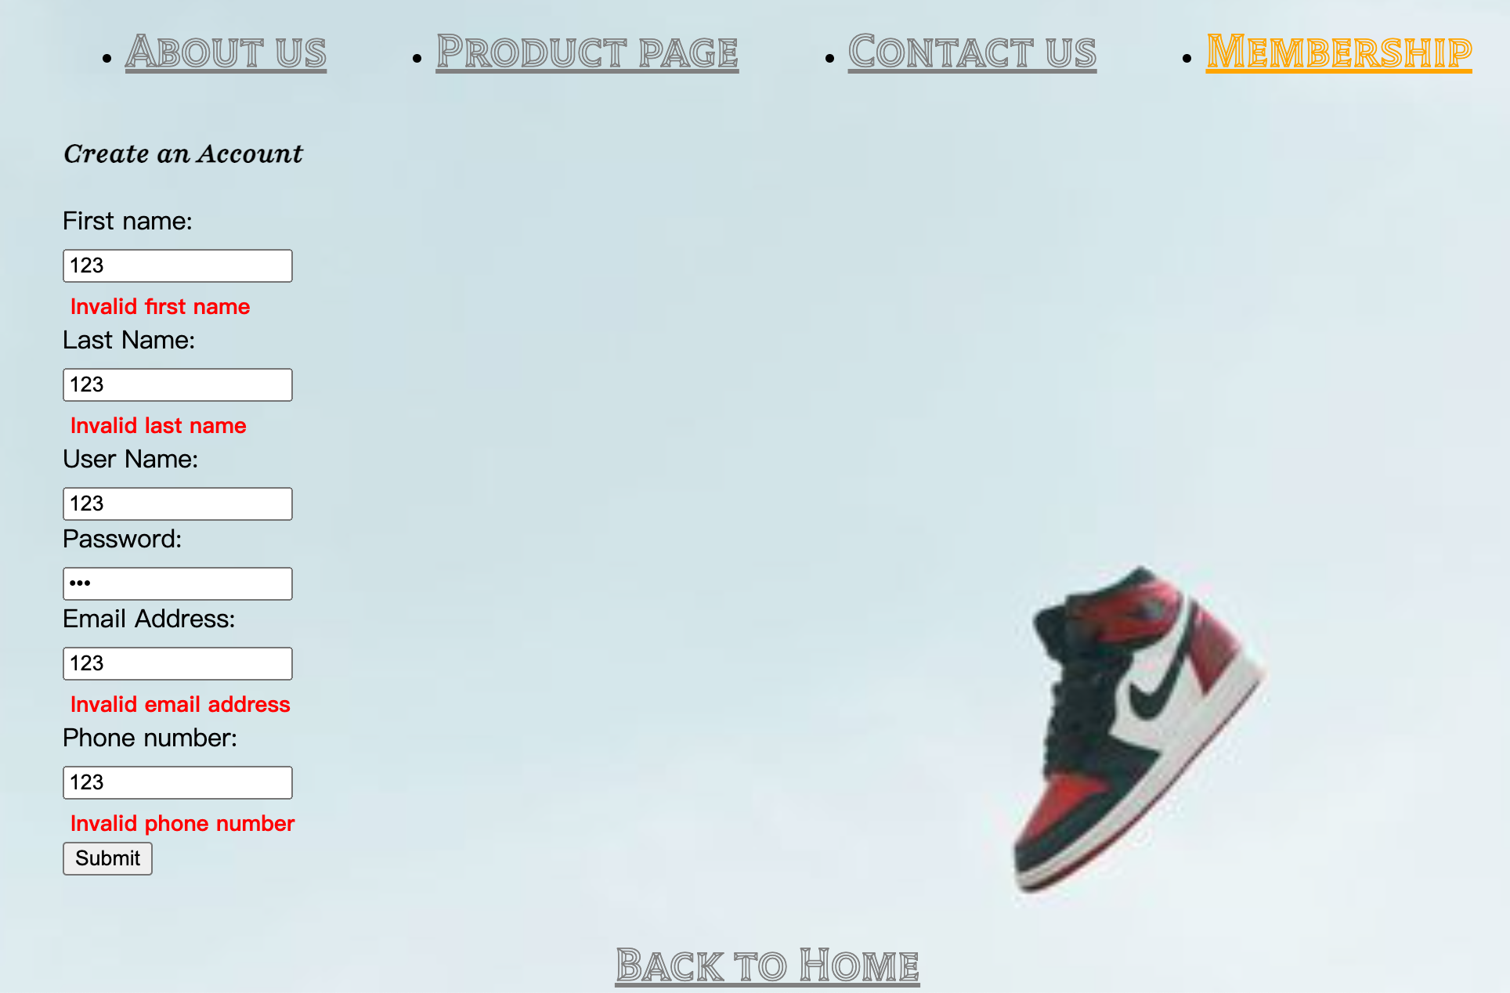

**In Membership page:**

In this page, users are able to login by typing their user name and password which they created in join us page. If the values meet the account database, then the browser will show “Successfully login!”. In the meantime, we haven’t created the account dummy data yet so the test value will not able to login.

If users are typing the incorrect account or password, will have different error message pop out. Detail as follow:

* User input invalid account (not yet registered): Show “Incorrect account. Would you like to create one?” This is to guide user to become one of our members.
* User input valid account but incorrect password: Show “Incorrect password”. To notify users that they need to check the password and retype it again.

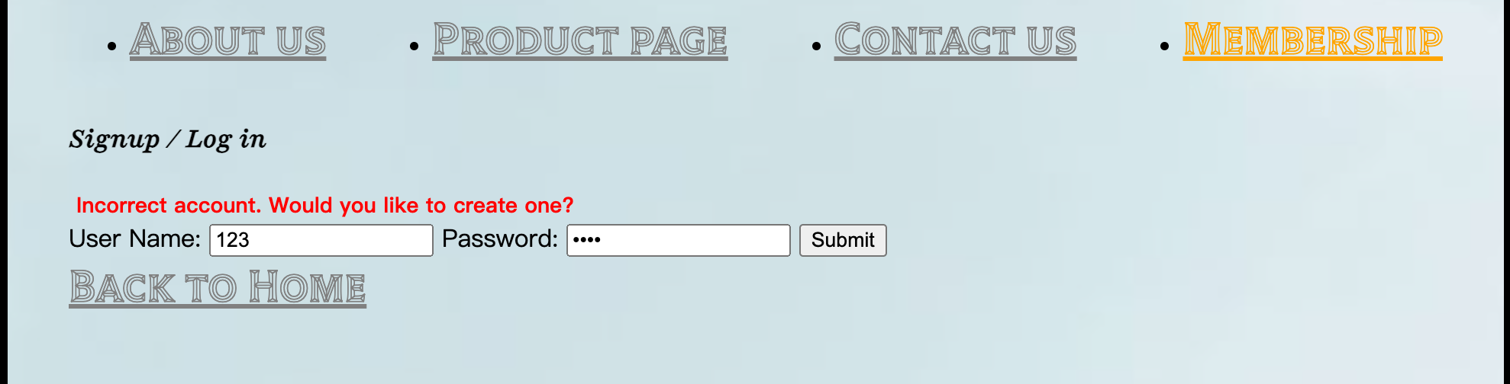

**In Contact Us Page**

In this page, members are able to contact our staff if they have any problems regarding orders or the products. We provided the contact numbers and online form for them to decide what kind of method they want to reach out to us.

If they decided to leave a note, they will need to provide the information. For example, their first name, last name, email address, phone number, and inquiry. We also set several requirements in each boxes to prevent unnecessary error.

Here is the detail:

* First name: Must be all characters, not accepting numbers.
* Last name: Must be all characters, not accepting numbers.
* Email address: Accepting characters and numbers. But need to meet the legal email address form. Such as @+xx.com.
* Phone number: Must be all numbers and at least 10 numbers.
* Inquiry: Accepting characters and numbers. But need to have at least 10 words for our staff to have better assistance. We think that by setting this restrictions would increase the speed of our staff to help our customers.

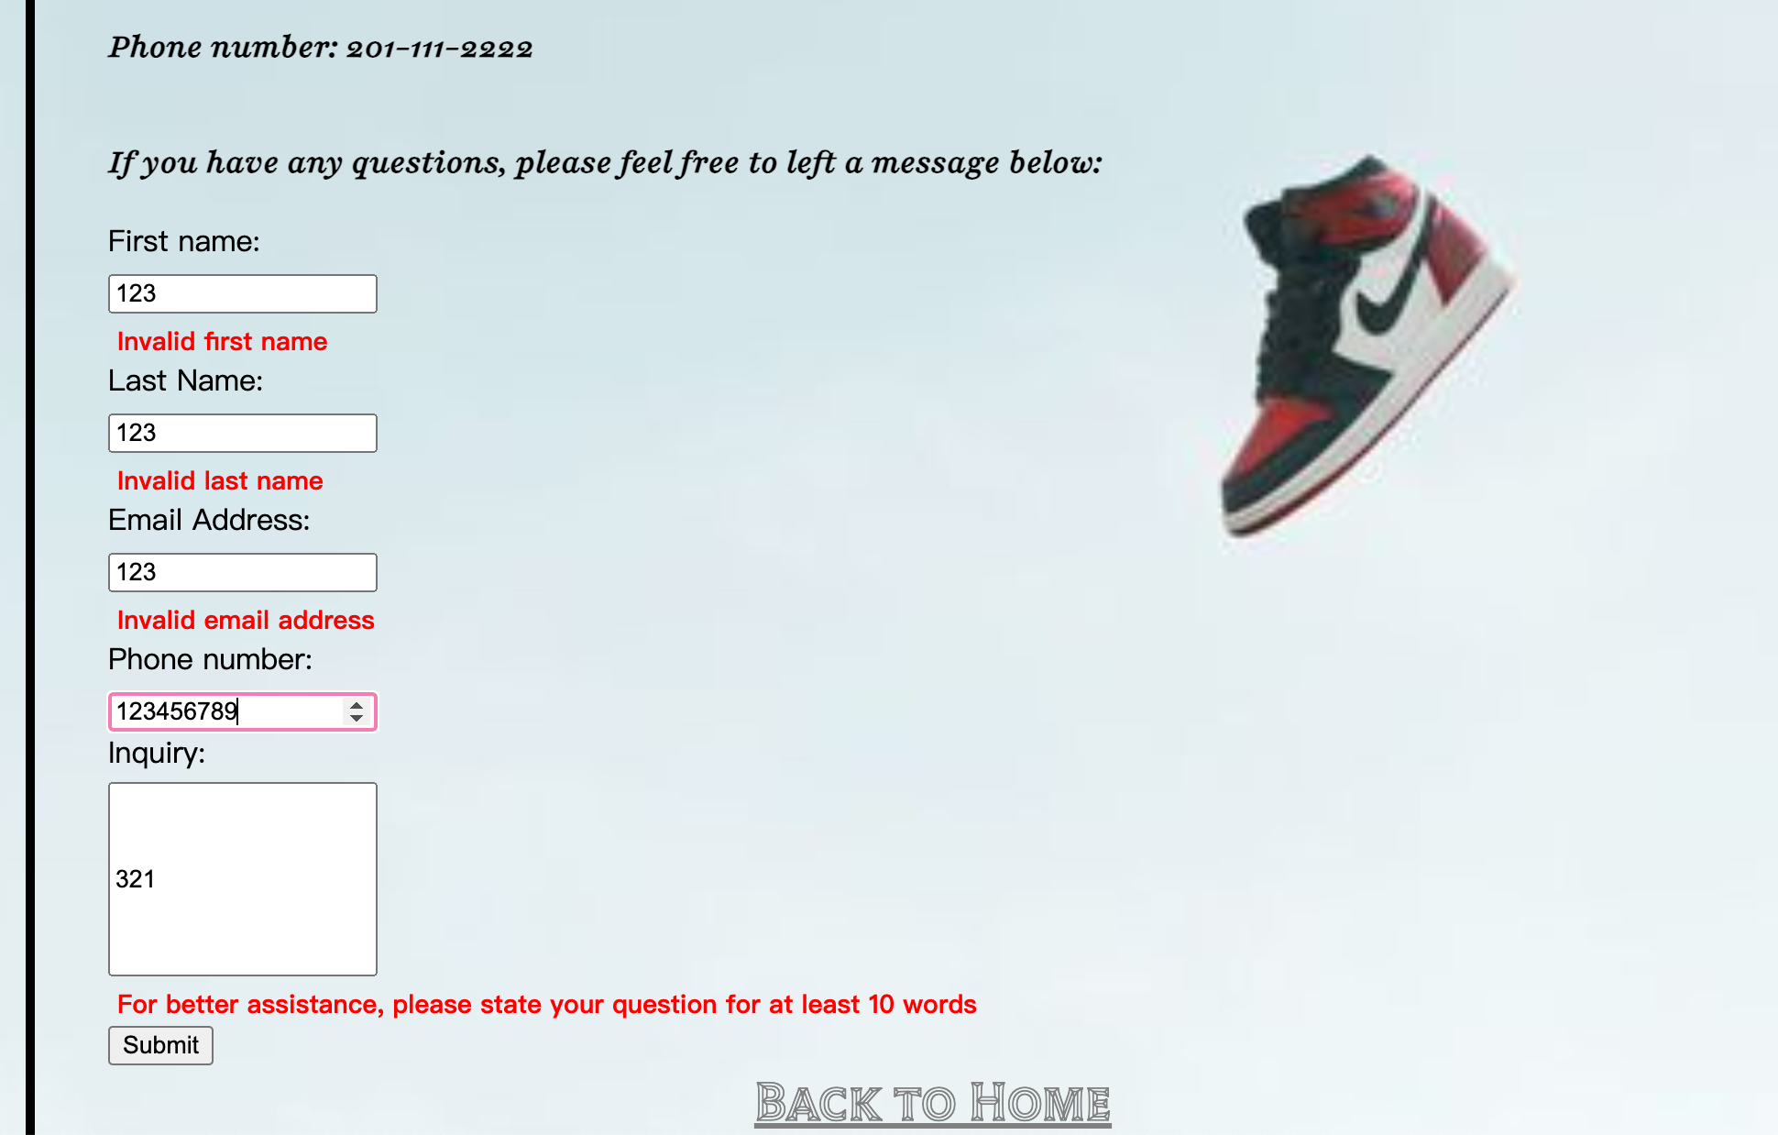

**Database**

The contact us page and create membership page have several blocks that allow user to input their unique value. Therefore, we created a database by MySQL with two tables, called memberData and customerService. We can connect the databases by implement an file called “app.js” using express and node.js. By using these tables, we are able to store and fetch customer’s data and for any purposes include login by the designing the columns. Moreover, it is also easy to maintain for future purposes.

Database table code(MySQL):

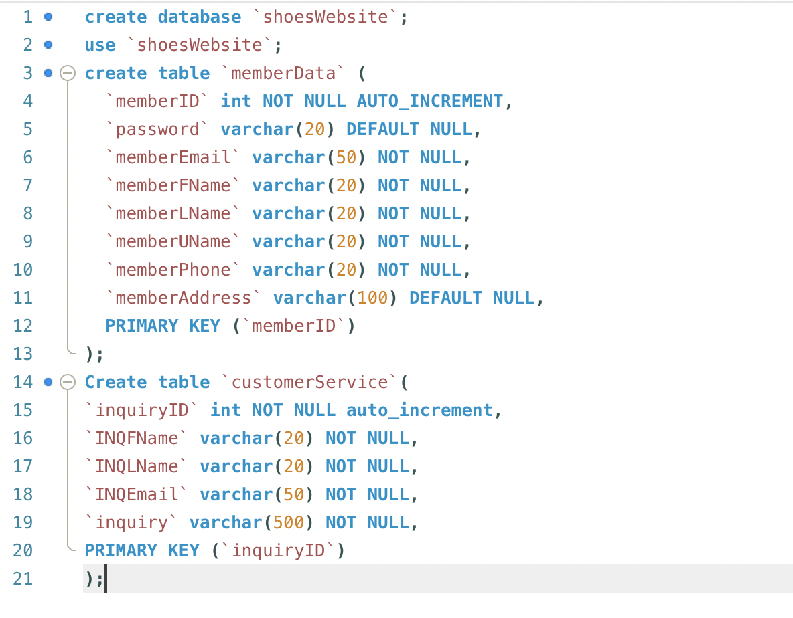

App.js file code:

*// 加载Express模块*

const express = require("express");

*// 加载MySQL模块*

const mysql = require("mysql");

*// 加载bodyParser模块*

const bodyParser = require("body-parser");

*// 加载MD5模块*

const md5 = require("md5");

*// 创建MySQL连接池*

const pool = mysql.createPool({

host: "127.0.0.1", *//MySQL服务器地址*

port: 3306, *//MySQL服务器端口号*

user: "root", *//数据库用户的用户名*

password: "", *//数据库用户密码*

database: "reg_log", *//数据库名称*

connectionLimit: 20, *//最大连接数*

charset: "utf8", *//数据库服务器的编码方式*

});

*// 创建服务器对象*

const server = express();

server.use(

bodyParser.urlencoded({

extended: false,

})

);

*// 加载CORS模块*

const cors = require("cors");

*// 使用CORS中间件*

server.use(

cors({

origin: ["http://localhost:8080", "http://127.0.0.1:8080"],

})

);

*//用户注册接口*

server.post("/register", (req, res) => {

*//console.log(md5('12345678'));*

*// 获取用户名和密码信息*

let username = req.body.username;

let password = req.body.password;

*//以username为条件进行查找操作，以保证用户名的唯一性*

let sql = "SELECT COUNT(id) AS count FROM reg_log WHERE username=?";

pool.query(sql, [username], (error, results) => {

*if* (error) *throw* error;

let count = results[0].count;

*if* (count == 0) {

*// 将用户的相关信息插入到数据表*

sql = "INSERT reg_log(username,password) VALUES(?,MD5(?))";

pool.query(sql, [username, password], (error, results) => {

*if* (error) *throw* error;

res.send({

message: "ok",

code: 200,

});

});

} *else* {

res.send({

message: "user exists",

code: 201,

});

}

});

});

*// 用户登录接口*

server.post("/login", (req, res) => {

*//获取用户名和密码信息*

let username = req.body.username;

let password = req.body.password;

*// SQL语句*

let sql =

"SELECT id,username FROM reg_log WHERE username=? AND password=MD5(?)";

pool.query(sql, [username, password], (error, results) => {

*if* (error) *throw* error;

*if* (results.length == 0) {

*//登录失败*

res.send({

message: "login failed",

code: 201,

});

} *else* {

*//登录成功*

res.send({

message: "ok",

code: 200,

result: results[0],

});

}

});

});

*// 指定服务器对象监听的端口号*

server.listen(3000, () => {

console.log("server is running...");

});

If the databases connect with the app.js successfully, we will see:

